Fast**National University of Computer & Emerging Sciences, Karachi  
Fall-2019 CS-Department**

**CS211-Discrete Structures**

**Practice Assignment-III**

**Note:**

1. **This is hand written assignment.**
2. **Just write the question number instead of writing the whole question.**
3. **You can only use A4 size paper for solving the assignment.**

**Maximum Marks: 25**

**Submission date: Monday, November 25, 2019 from 10-12 noon at my office.**

1. **Consider the tree shown at right with root a.**

**a. What is the level of n? b. What is the level of a?**

**c. What is the height of this rooted tree? d. What are the children of n?**

**e. What is the parent of g? f. What are the siblings of j?**

**g. What are the descendants of f? h. What are the internal nodes?**

**i. What are the ancestors of z? j) What are the leaves?**

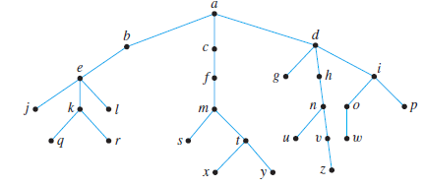

1. **Use Kruskal’s and Prim’s algorithm to find a minimum spanning tree for each of the graphs. Indicate the order in which edges are added to form each tree.**

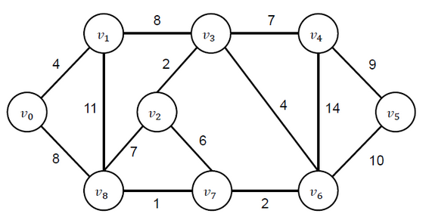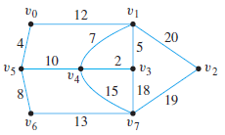**a) b)**

1. **(a) Build a binary search tree for the word’s banana, peach, apple, pear, coconut, mango, and papaya**

**using alphabetical order.**

**(b)**

**(i) How many edges does a tree with 10000 vertices have?**

**(ii) How many edges does a full binary tree with 1000 internal vertices have?**

1. **(a) Determine the order in which preorder, Inorder and Postorder traversal visits the vertices of the given ordered rooted tree.**

**a) b)**

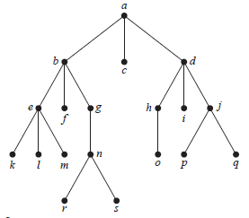 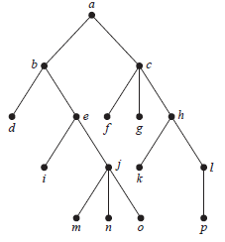

**(b) Represent these expressions (x + xy) + (x / y) and x + ((xy + x) / y) using binary trees.**

1. **(a) Write these expression (x + xy) + (x / y) and x + ((xy + x) / y) in:**

**i) prefix notation. ii) postfix notation. iii) Infix notation.**

**(b) (i) What is the value of this prefix expression + – ↑ 3 2 ↑ 2 3 / 6 – 4 2**

**(ii) What is the value of this postfix expression 4 8 + 6 5 – * 3 2 – 2 2 + * /**

1. **(a) An office building contains 27 floors and has 37 offices on each floor. How many offices are in the building?**

**(b) A particular brand of shirt comes in 12 colors, has a male version and a female version, and comes in three sizes for each sex. How many different types of this shirt are made?**

1. **(a) How many different three-letter initials can people have?**

**(b) How many different three-letter initials with none of the letters repeated can people have?**

1. **(a) A wired equivalent privacy (WEP) key for a wireless fidelity (WiFi) network is a string of either 10, 26, or 58 hexadecimal digits. How many different WEP keys are there?**

**(b)** **How many strings are there of four lowercase letters that have the letter x in them?**

1. **(a) How many functions are there from the set {1*,* 2*, . . . , m*}, where *m* is a positive integer, to the set {0*,* 1}?**

**(b) How many one-to-one functions are there from a set with five elements to sets with five elements?**

1. **(a) Use a tree diagram to determine the number of subsets of {3*,* 7*,* 9*,* 11*,* 24} with the property that the sum of the elements in the subset is less than 28.**

**(b) Teams A and B play in a tournament. The team that first wins two games wins the tournament. Find the number of possible ways in which the tournament can occur.**

1. **(a) Eight members of a school marching band are auditioning for 3 drum major positions. In how many ways can students be chosen to be drum majors?**

**(b) You must take 6 CS elective courses to meet your graduation requirements at FAST-NUCES. There are 12 CS courses you are interested in. In how many ways can you select your elective Courses?**

**(c) Nine people in our class want to be on a 5-person basketball team to represent the class. How many different teams can be chosen?**

1. **(a) A committee of five people is to be chosen from a group of 20 people. How many different ways can a chairperson, assistant chairperson, treasurer, community advisor, and record keeper be chosen?**

**(b) A relay race has 4 runners who run different legs of the race. There are 16 students on your track team. In how many ways can your coach select students to compete in the race? Assume that the order in which the students run matters.**

**(c) Your school yearbook has an editor in chief and an assistant editor in chief. The staff of the yearbook has 15 students. In how many ways can a student be chosen for these 2 positions?**

1. **(a) A deli offers 5 different types of meat, 3 types of breads, 4 types of cheeses and 6 condiments. How many different types of sandwiches can be made of 1 meat, 2 bread, 1 cheese, and 3 condiment?**

**(b) Police use photographs of various facial features to help eyewitnesses identify suspects. One basic identification kit contains 15 hairlines, 48 eyes and eyebrows, 24 noses, 34 mouths, and 28 chins and 28 cheeks. Find the total number of different faces.**

1. **(a) How many bit strings of length 10 either begin with three 0s or end with two 0s?**

**(b) How many bit strings of length 5 either begin with 0s or end with two 1s?**

1. **(a) Show that if there are 30 students in a class, then at least two have last names that begin with the same letter.**

**(b) Assuming that no one has more than 1,000,000 hairs on the head of any person and that the population of New York City was 8,008,278 in 2010, show there had to be at least nine people in New York City in 2010 with the same number of hairs on their heads.**

**(c) There are 38 different time periods during which classes at a university can be scheduled. If there are 677 different classes, how many different rooms will be needed?**

1. **(a)What is the coefficient of x5 in (1 + x)11?**

**(b)What is the coefficient of a16b17 in (a + b)24?**

1. **(a) Prove that for all integers a, b and c, if a|b and b|c then a|c.**

**(b) Prove that for all integers a, b and c if a|b and a|c then a|(b+c)**

1. **(a) Prove the statement: There is an integer n > 5 such that 2n – 1 is prime.**

**(b) Prove that for any integer a and any prime number p, if p | a, P | (a + 1).**

1. **(a) Prove the statement: There are real numbers a and b such that $\sqrt{(a+b})$ = $\sqrt{a}+\sqrt{b}$.**

**(b) Prove that if |x| > 1 then x > 1 or x < –1 for all x € R.**

1. **(a) Prove or disprove that the product of any two irrational numbers is an irrational number.**

**(b) Prove that the sum of any rational number and any irrational number is irrational.**

1. **(a) Find a counter example to the proposition: For every prime number n, n + 2 is prime.**

**(b) Show that the set of prime numbers is infinite.**

1. **(a) Prove by contradiction method, the statement: If n and m are odd integers, then n + m is an even integer.**

**(b) Prove the statement by contraposition: For all integers m and n, if m + n is even then m and n are both even or m and n are both odd.**

1. **(a) Prove by contradiction that 6 – 7 $\sqrt{2}$ is irrational.**

**(b) Prove by contradiction that $\sqrt{2}$ + $\sqrt{3}$ is irrational.**

1. **(a) A 6-sided die is rolled twice.** **what is the probability of following events?**

**i) The sum of the two numbers is 6.**

**ii) The sum of the two numbers is 7.**

**iii) The larger of the two numbers is 4.**

**(b) What is the probability that a positive integer less than 100 picked at random has all non-distinct digits?**

1. **By mathematical induction, prove that following is true for all positive integral values of n.**

**(a) 12+ 22+ 32+ …… + n= (n(n+1)(2n+1))/6**

**(b) 1+2+22 + … + 2n = 2n+1 – 1 for all integers n ≥0**